Volunteering at

Polka Theatre
Volunteer Role Description
Thank you for your interest in becoming a Polka Volunteer! This role description is designed to help you decide if volunteering at Polka is the right fit for you.

"The place to be for children's theatre" ayoungertheatre.com

The role:
To act as the public face of Polka Theatre, assisting with the day-to-day running of the venue, ensuring that our visitors and audiences have an enjoyable and safe experience.

Are you?
- Friendly and able to interact with children, young people and their families?
- Interested in theatre or the arts?
- Wanting to learn new skills?
- Enthusiastic about meeting new people?
- Able to work well in a diverse team of people?
- Wanting to engage with a local charity and community?
If so, we would love to hear from you! Read on to find out more about the role and how to apply!

Why volunteer?
Whether you want to gain new skills, make new friends or to engage with your community in our truly unique venue, people volunteer with us for many reasons:
'I volunteered at Polka because as a recently retired teacher, I had some time on my hands and wanted to help out in the local community. I am very much aware of how much children benefit from the magic of live performance, and I am particularly impressed with how the Polka reach out to children who may normally be unable to access live theatre.' - Sue, Volunteer

'I've really enjoyed volunteering at Polka; it's been great developing my skills in such a positive environment.' - George, Volunteer

'Volunteering at Polka has truly been one of the best decisions I have made. Through this incredible opportunity I was able to learn so much about what it takes to put on a production at a professional theatre - it has been invaluable work experience.' - Rachel, Volunteer

Key Duties as a Polka Volunteer could include:
- Welcoming all visitors to Polka, ensuring they are safe and happy throughout their visit
- Acting as a good ambassador for charity by supporting our vision and values
- Undertaking duties both inside and outside the theatres
- Assisting in emergency evacuations of the venue (full training will be given)
- Answer visitor enquiries and solve problems
- Ensuring that our spaces are clean, tidy and accessible to guests
- Selling merchandise and refreshments in theatres and from our Polka Shop
- Representing Polka by wearing the Polka Volunteer uniform (you will be provided with a Polka Team Member t-shirt)

Please note the minimum age requirement to become a Polka Volunteer is 16.

As a Polka Volunteer you will receive:

  - A free ticket for Polka productions in line with our staff and volunteers ticket policy, as well as exclusive ticket offers, subject to availability
  - Invitations to social events taking place at Polka and beyond
  - A 30% discount in our Polka Cafe and 20% in our Polka Shop
  - Invitations to additional training opportunities that we regularly run at Polka

Volunteer Shifts:

We understand that in order to fit volunteering around your busy schedule, we need to be flexible when asking for your time and effort. We require a minimum commitment of just two shifts per month, although many of our volunteers choose to do more!

An average shift lasts approximately 3 hours, with start and finish times dependent on the timings of the performances and events taking place that day.

  - Morning shifts usually start at 9:30am and Afternoon shifts at 12:30pm

  - There are also shorter shifts available on weekday afternoons, usually from 3:30pm – 5pm.

There will also be other ad hoc events and opportunities that volunteers can take part in throughout the year.

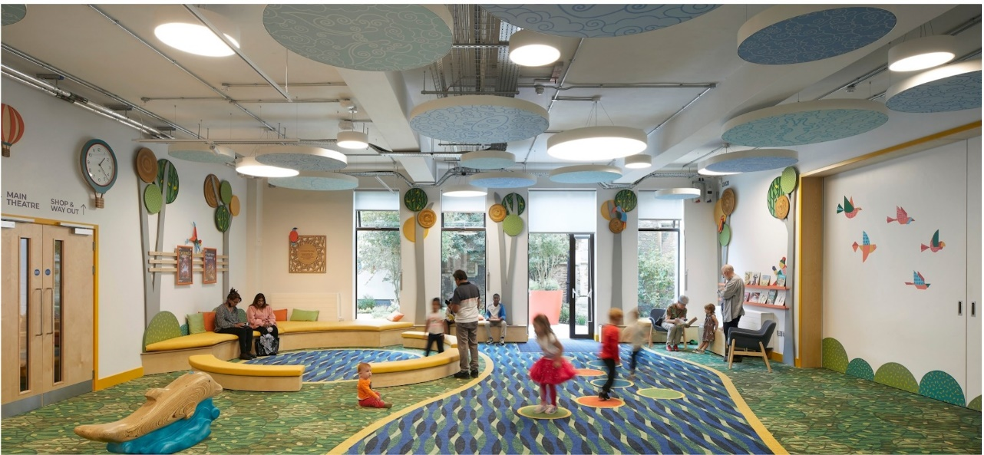
Valuing our Volunteers:
We reimburse travel expenses up to £7.00 per day as we feel that nobody should be out-of-pocket or feel they can't volunteer at Polka due to financial constraints. These reimbursements are made monthly and require receipts.

How to apply:
We use the volunteering platform Be Collective to take volunteer applications. Please create a Be Collective account, using this link: https://uk.becollective.com/register and apply to join our group 'Polka Theatre' Links to the above can also be found on our website:
https://polkatheatre.com/volunteering

Want to find out more about what it takes to be a Polka Volunteer? We run regular open events where you have the chance to meet some of the Polka Team, have a tour of our unique building and ask any questions you may have. To find out when the next one is taking place, please email volunteer@polkatheatre.com

What happens after you submit your application:

Your application will be reviewed, and we will be in contact to let you know if you have been successful.

If we feel that the role would be a good fit for you, the next step is to invite you to Polka for an informal chat with one of our team members.

After we have met you, we will contact you to let you know if you have been successful in joining our team.

We will send you the necessary paperwork and training materials. Your first two volunteering shifts will be a trial.

If your trial goes well, you continue to volunteer, signing up to a minimum of two shifts per month.
We hope that this role description has been informative and that you will apply to join our team! If you have any further queries or would like this document in a different format please contact us via email at volunteer@polkatheatre.com where we will endeavour to reply to your query within two working days.
