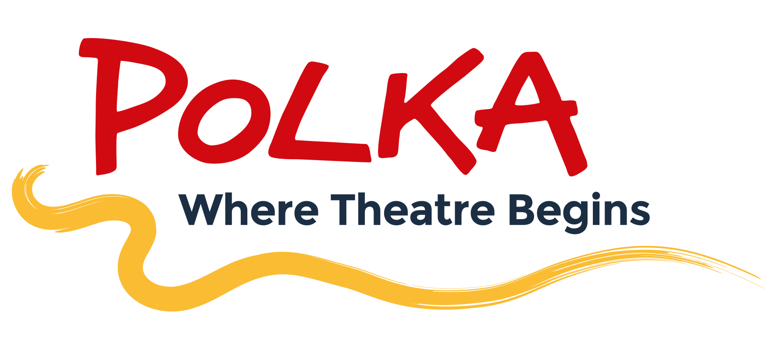

Polka Volunteer Policy
Meaningful volunteering opportunities

Glossary (Polka definitions that hold within this document):

Volunteer – a person who freely gives their time, unpaid, to a formal activity undertaken through Polka;

Placement Student – a student who freely gives their time, unpaid, to formal activities through Polka, as organised through an educational body, and as part of the requirements of a particular educational course.

Volunteers and placement students are not employees and are not covered by employment law.

This policy does not cover internships – at Polka, we do not provide unpaid internships. Therefore, by definition, a Polka Intern would always be treated as a paid employee, and thereby would fall under policies covering paid employees.

Polka’s volunteers and placement students are an important part of our team and support us in a range of ways that add value to our organisation. Polka is committed to providing volunteers and placement students with a structured and supportive working environment where they can learn new skills, develop personally and professionally, and actively contribute to the daily life of Polka. This policy is designed to make sure all volunteers and placement student are treated fairly and managed consistently, and what they can do if they feel things are not going as well as they would like. It also explains what you can expect from Polka as a volunteer or placement student and what Polka expects from our volunteers and placement students as an important part of the wider team.

Where possible and appropriate, Polka is committed to supporting volunteers and placement students on their way to paid employment if that is their aim. This may be through giving references and recommendations for roles outside of Polka, or, where appropriate, identifying roles at Polka which volunteers and placement students could be suited to.

What volunteers can expect from Polka

Polka’s Volunteer and Visitor Services Coordinator oversees and supports all volunteers at Polka. Placement students, and some other specialist volunteers are overseen by department heads. Volunteers and placement students will be further supported by the most appropriate person based on the activity they are doing. E.g. a placement student working backstage may be supported by one of our Technical team. These staff members at Polka will support and monitor the progress of volunteers and placement students by:

- Conducting an appropriate induction.
- Making sure Polka have their correct contact details, including emergency contacts.
- Providing any support, resources and training to undertake their activities.
- Creating opportunities for 1-1 sessions to reflect on their experiences of undertaking their volunteering role or placement. For placement students these will take place at least annually or at the end of the placement if it is for less than a year.
- Make sure they know how to claim for any out-of-pocket expenses.

What Polka expects from its volunteers

Volunteers are ambassadors / representatives of Polka, and so we expect them to follow our values at all times and uphold our standards. Volunteers and placement students are not paid, but in order to benefit from the experience, Polka does expect a level of commitment. If the expectations below are not being met then Polka will review the arrangement, discuss it with volunteer or placement student, and end the arrangement if necessary.

- Adhere to an agreed guideline of hours, instructions and guidelines from your supervisor and other Polka staff, where relevant.
- Be punctual, and contact us as soon as possible if you are running late or unable to come in.
- Be a team player and support Polka staff by listening and taking an active part in the work being done.
- Be open to new ideas and ways of working.
- Make sure you observe confidentiality of Polka staff and project participants.
- Ask questions when you are not sure.
- Observe and adhere to our policies, guidelines and risk assessments appropriate to your role.

Student Placements

Placement students from an educational body will often spend more time at Polka and have more of an overview across projects, and so they are often asked to take on additional responsibilities, or to complete specific projects. A project would be something that is beneficial to both Polka and their own personal development, and that fits with the requirements of the student’s course.

We aim to give students undertaking placements a realistic and overall experience of working for anarts organisation.

How to become a Volunteer

As a registered charity we can’t operate without volunteers who help us welcome our community to our venue, and create a safe and accessible environment for them. If you are interested in joining us please read the Information Pack on our website and apply on Be Collective. We use the volunteering platform Be Collective to receive volunteer applications. Please create a Be Collective account, using this link: Be Collective and apply to join our group 'Polka Theatre'.

If you are interested in other areas of volunteering throughout the charity, please do contact us for a chat. Please note that the minimum age to volunteer is 16. If you are a student under age 16 looking to do work experience at Polka please visit our work experience page. If you are interested in a Student Placement this usually through your University or College.
If you have any questions, please contact us on volunteer@polkatheatre.com or call us on 020 8543 4888. Alternatively, a Volunteer Information Pack can be obtained in person from the Polka Box Office
Criminal record checks and safeguarding

Polka requires that volunteers and placement students undertake Enhanced DBS checks that cover work with children in the following circumstances:

- If undertaking regular activity with children or young people.
- This includes volunteering on a project including 3+ regular workshops or events with participants

If a volunteer or placement student is not undertaking regular activity with Polka’s participants but they will be in contact with them on an irregular basis, then the supervisor of the project should ensure the volunteer or placement student is not left alone with participants.

All procedures - in line with Safeguarding Children Policy and Procedures - must be read and followed accordingly.

All volunteers are encouraged to attend the regular Safeguarding Training offered in-house. This, along with other day-to-day briefings and induction, will help you to understand how to safeguard both children and yourself, to avoid putting yourself at risk as a volunteer. Volunteers should never be alone with a child – if in any doubt always seek the advice of a manager.

Support, supervision and feedback

When you join Polka as a volunteer you will have an induction appropriate to your role with the person responsible for supporting you whilst you are volunteering and as part of your induction you may meet with other members of the team. Your induction will cover, as a minimum, the following:

- Making sure you have provided the correct details on Be Collective, including appropriate emergency contact details for you.
- Making sure you have access to, and have read and understood any policies and procedures relating to your role. As a minimum this will include Polka’s Privacy Notice, Social Media Guidelines, Volunteer Problem Solving Procedure, Child Protection and Safeguarding Procedure, Data Protection, Equality, diversity and inclusion, Expenses, Health and Safety and Adults at Risk Safeguarding.
- A description of your volunteer role and responsibilities.
- How you can contact the person responsible for your volunteering and the rest of the team as needed for support.
- How to claim travel expenses if applicable.
- Check you are aware of what to do if you are looking to volunteer whilst on benefits.

There is the opportunity to have a 1-1 meeting with the person responsible for supporting you as a volunteer at least annually to discuss how your role is going and any development needs you may have. The person responsible for supporting your volunteering will also check-in with you more informally if necessary You can also ask to speak with that person about how you are feeling in your volunteer role as well as how you are progressing at any point. You can and are encouraged to ask for support and discuss your training and development needs.

There are regular opportunities to feedback, both informally through speaking to the Volunteer Coordinator or other staff member, or more formally through surveys or other written feedback.

Volunteer voices and recognition

We look to retain volunteers by making sure we provide them with feedback, support and most importantly thanking them. Recognition throughout the year includes awarding pin badges for number of hours volunteered, Volunteer of the Month profiles, and regular social and celebratory events.

Expenses

Travel expenses that are incurred directly as a result of your volunteering activity can be reimbursed. The amount is up to £7 per day.
Please note that Polka can only reimburse expenses after volunteering has taken place and where receipts are provided.

In addition, where a volunteering period covers a lunch time, you can claim food and drink worth up to £5 in the Polka café, using our café voucher scheme.

Insurance

Volunteers and placement students are covered by Polka’s insurance policy.

Confidential data and Data Protection

Some volunteers or placement students might have access to personal or confidential data relating to Polka or it’s projects. Any data shared with you as part of your role must be kept strictly confidential and handled in accordance with Polka’s Data Protection Policy. If you have any questions or concerns about how to handle data, please discuss this in advance with your supervisor.

Problem solving

We hope that you will enjoy your time volunteering with Polka and contributing to the work of the charity. Although the relationship between Polka and any volunteers is entirely voluntary, it is important that the relationship works for both Polka and you as a volunteer. If any problems do arise, you can raise these informally with the person supporting your volunteering, or the Volunteer and Visitor Services Coordinator, or they may raise them with you. Please refer the Volunteer Problem Solving Procedure for more information.

The Executive Director is responsible for managing any complaints that cannot be resolved informally.

Endings
When your volunteering with Polka comes to an end you will be offered the opportunity to have an end of volunteering meeting with the Volunteer and Visitor Services Coordinator, if appropriate.

